Kinney 3
What
The Statement of Cash Flows (“SCF”) has consistently been a leading area of restatements. Notably, a large proportion of cash flow restatements are disclosed as “little r” restatements, implying that issuers and auditors view SCF errors, which are primarily classification related, as immaterial. Former SEC Chief Accountant, Paul Munter, recently raised issue with this practice, reminding issuers and auditors that errors stemming from incorrect classification do not necessarily imply the error was immaterial. In fact, the informativeness of the SCF relies on correct classification of cash flow items within each section. These trends suggest that preparers and auditors may be applying a lower threshold of scrutiny to SCF errors compared to other financial statements. Accordingly, we examine whether SCF errors are systematically treated as immaterial relative to other types of errors, and whether these errors materially affected financial statement users.
Why
This research is important because the SCF is a required financial statement and a critical source of information for investors, creditors, and other financial statement users. Therefore, understanding whether the SCF is prepared and audited to the same standard as other financial statements is essential for users who rely on cash flow information for valuation, credit analysis, liquidity assessment, and contracting. This research is also important for auditors and regulators. For auditors, evidence of a mismatch between auditors’ and financial statement users’ perceptions of the materiality of SCF errors could lead to revised audit risk assessments and audit procedures. For regulators, our research is timely and could inform enforcement decisions given the recent concerns from the SEC about SCF materiality practices.
How
- Descriptives
  - Figure 1: Yearly percentage of misstatements with SCF error compared to other common GAAP errors (misstatement level)
  - Table X: Use XBRL tags to quantify the most frequent SCF line-items that are misstated. Quantify frequency main subsection totals change as a result. (misstatement level)
- RQ1: Are preparers/auditors more likely to view SCF misstatements as immaterial relative to other types of errors?
  - Table 1: Broadly test whether various types of errors in GAAP are more or less likely to be disclosed as restatement vs revision/adjustment (misstatement level)
  - Table: Difference in disclosure method for cash flow misstatements (misstatement level)
    - $Revision= α+ β SCF Error+Controls+ ε$
    - Prediction: SCF Error is positive suggesting misstatements with a cash flow error are more likely to be disclosed as a revision or out of period adjustment than a restatement controlling for characteristics of the misstatement.
  - Table: Is the difference in disclosure method for cash flow misstatements explained by materiality thresholds by regulators or potential effects on financial statement users? Split SCF Error into two dummies of small and big changes based on thresholds such as: explicit auditing materiality benchmarks, error enabling meet/beat CFO expectations, error in CFO near covenant thresholds, or corresponding change in I/S or B/S)?
    - $Revision = α+ β SCF Error:SmallChg+β SCF Error :BigChg+Controls+ ε$
    - Prediction: There is no difference between coefficients on material/big SCF changes suggesting there is no difference in disclosure decision based on magnitude of cash flow change.
- RQ2: Do SCF errors have negative consequences to financial statement users?
  - Table: Would the adjusted cash flow measures from the misstatement have led to better predictions of future cash flows or improvements to bankruptcy prediction models? (firm-year level from the period that was ultimately misstated)
    - ${CF}_{t+1}= α+ β {CFO}_{t}^{Orig}+β {CFI}_{t}^{Orig}+ β {CFF}_{t}^{Orig}+ ε$
    - ${CF}_{t+1}= α+ β {CFO}_{t}^{Adj}+β {CFI}_{t}^{Adj}+ β {CFF}_{t}^{Adj}+ ε$
    - Prediction: Voung likelihood test that the Adj R² (or AUC/F1 Score for binary outcomes like bankruptcy prediction) from the model using adjusted cash flow measures is higher than the Adj R² from the model using the originally reported numbers. First, use sample misstatement periods from all types of misstatement and then sub-samples based on restatements and revision classification. If there is meaningful improvement from revision sample, it would suggest that SCF errors that are viewed as immaterial could have meaningfully changed investors’ predictions of future cash flows.
  - Table: Do periods with SCF errors lead to more analyst CFO forecast errors? (firm-year observations with CFO forecast from IBES)
    - ${\left|CFO Fcst Error\right|}_{t+1}= α+ β {|ΔCFO|}_{t}+ Controls+ ε$
    - Prediction: Among firms with a CFO forecast, periods where the most recently reported CFO actuals were subsequently misstated are positively associated with analysts’ CFO forecast errors.
    - ${\left|CFO Fcst Error\right|}_{t+1}= α+ β {\left|ΔCFO\right| x BigR}_{t}+ β {\left|ΔCFO\right| x little r}_{t}+ Controls+ ε$
    - Prediction: If materiality judgements are not correctly applied for cash flow misstatements, both types of misstatements should be positively associated with forecast errors.
  - Table: Are returns predictably higher (lower) for periods following a filing with SCF error where CFO was originally understated (overstated)? (firm-year level from the period that was ultimately restated)
    - ${Return}_{t+k}= α+ β {ΔCFO}_{t}+ MKT+ SMB+HML+RMW+CMA+ ε$
    - Prediction: Positive coefficient if change in CFO from error predicts mispricing through k months financial statement filed in month t. If positive effect still exists for SCF errors that are subsequently revealed via a revision it would be more evidence that classification errors considered immaterial have material consequences.
- Cross-sections
  - Types of firms (highly levered firms; close to covenant thresholds; those with CFO forecast)
  - Auditor busyness; Auditor independence
  - SCF complexity (number of line items within SCF)
- Other potential consequences
  - Table: Do loan spreads change following revelation of SCF error?

Results

Figure 1: Percentage of misstatements with cash flow statement error by year

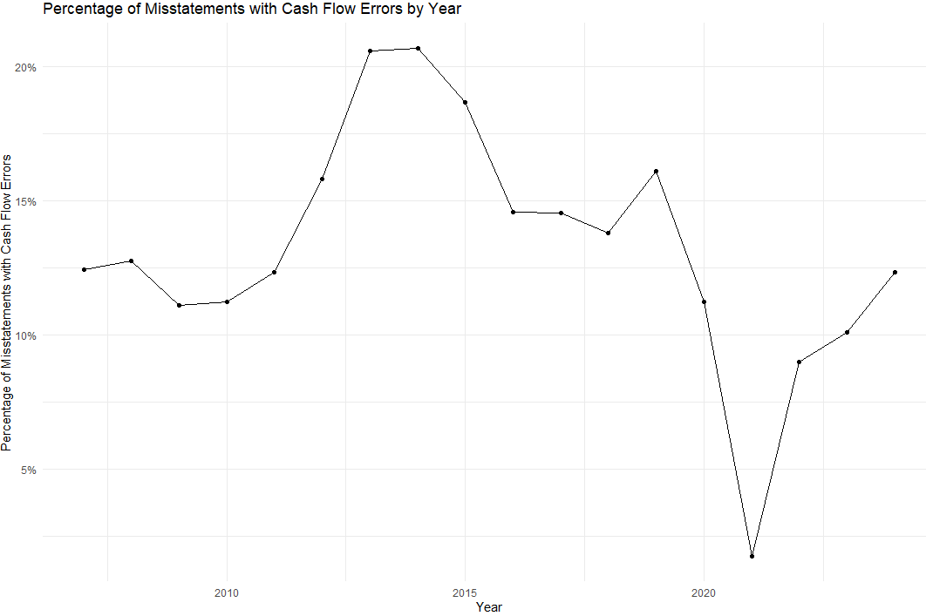

Table 1: Audit Analytic Misstatements by Error Type and Disclosure Method
Error Type | Total | Restate (#) | Revision (#) | Adjust (#) | Restate (%) | Revision (%) | Adjust (%) | Test Statistic | P-Value
Tax expense | 2,425 | 411 | 1,012 | 1,002 | 16.9% | 41.7% | 41.3% | -16.164 | 0.000
Cash flow statement | 1,766 | 276 | 1,461 | 29 | 15.6% | 82.7% | 1.6% | -14.980 | 0.000
Liabilities | 1,819 | 452 | 979 | 388 | 24.8% | 53.8% | 21.3% | -6.794 | 0.000
Footnote & segments | 443 | 78 | 322 | 43 | 17.6% | 72.7% | 9.7% | -6.612 | 0.000
Operating expenses | 1,800 | 480 | 981 | 339 | 26.7% | 54.5% | 18.8% | -5.109 | 0.000
Depreciation & amortization | 601 | 137 | 248 | 216 | 22.8% | 41.3% | 35.9% | -4.982 | 0.000
Balance sheet classification | 349 | 70 | 261 | 18 | 20.1% | 74.8% | 5.2% | -4.890 | 0.000
Intercompany transactions | 416 | 93 | 263 | 60 | 22.4% | 63.2% | 14.4% | -4.336 | 0.000
Consolidation | 1,351 | 365 | 635 | 351 | 27% | 47% | 26% | -4.151 | 0.000
Comprehensive income | 148 | 30 | 94 | 24 | 20.3% | 63.5% | 16.2% | -3.129 | 0.002
PPE | 648 | 176 | 280 | 192 | 27.2% | 43.2% | 29.6% | -2.797 | 0.005
Inventory & COGS | 1,064 | 302 | 510 | 252 | 28.4% | 47.9% | 23.7% | -2.731 | 0.006
Subsidiaries & related parties | 1,402 | 414 | 758 | 230 | 29.5% | 54.1% | 16.4% | -2.217 | 0.027
Other | 429 | 118 | 194 | 117 | 27.5% | 45.2% | 27.3% | -2.123 | 0.034
EPS and ratios | 557 | 165 | 381 | 11 | 29.6% | 68.4% | 2% | -1.350 | 0.177
Pension | 1,063 | 324 | 518 | 221 | 30.5% | 48.7% | 20.8% | -1.268 | 0.205
Derivatives | 245 | 71 | 124 | 50 | 29% | 50.6% | 20.4% | -1.111 | 0.267
Leases | 803 | 247 | 330 | 226 | 30.8% | 41.1% | 28.1% | -0.932 | 0.351
Gain/loss recognition | 241 | 74 | 108 | 59 | 30.7% | 44.8% | 24.5% | -0.529 | 0.597
Expense capitalization | 419 | 133 | 205 | 81 | 31.7% | 48.9% | 19.3% | -0.243 | 0.808
Assets | 1,263 | 411 | 668 | 184 | 32.5% | 52.9% | 14.6% | 0.185 | 0.853
Revenue recognition | 2,053 | 674 | 911 | 468 | 32.8% | 44.4% | 22.8% | 0.516 | 0.606
Registration | 79 | 37 | 41 | 1 | 46.8% | 51.9% | 1.3% | 2.763 | 0.006
Stock compensation | 1,383 | 500 | 673 | 210 | 36.2% | 48.7% | 15.2% | 3.066 | 0.002
Acquisitions, mergers, & reorg | 2,283 | 932 | 992 | 359 | 40.8% | 43.5% | 15.7% | 8.711 | 0.000
Auditor | 57 | 50 | 7 | 0 | 87.7% | 12.3% | 0% | 8.948 | 0.000
Debt and/or equity classification | 5,347 | 2,816 | 2,270 | 261 | 52.7% | 42.5% | 4.9% | 31.849 | 0.000
This table summarizes the frequency and reporting treatment of various types of errors from misstatements. 'Restatements', 'Revisions', and 'Adjustments' are the types of disclosure methods for a misstatement. 'Test Statistic' is a z-statistic comparing the restatement rate for each error type to the overall restatement rate. 'P-Value' is the two-tailed significance level for the test statistic.

